Managua, February 5th, 2020

His Excellency
Dr. Keith Mitchell
Prime Minister of Grenada
Saint George

Dear Prime Minister,

As you commemorate the 46th Anniversary of Independence of Grenada this February 7th, we wish to express our warmest congratulations to the Brotherly People and Government of Grenada, on behalf of the People and Government of Reconciliation and National Unity of the Republic of Nicaragua, and on our own behalf.

At this moment of Inspiration and National Pride, we are pleased to recognize the Path to Dignity, Self-determination and Development initiated in 1974, with your Declaration of Independence.

On this solemn occasion, we wish to express our recognition to the important advances made by the Government of Grenada, under your leadership, in favor of Stability, Peace, Prosperity and Well-being of your People.

Brother Prime Minister,

Our countries share a common History of Struggle for Development and Peace, for that, the Government of Nicaragua is proud to reiterate its unwavering commitment to continue strengthening the bilateral bonds of Brotherhood, Solidarity and Cooperation that unite our Peoples and Governments.

Receive the Fraternal Embrace from this our Blessed and Always Free Nicaragua.
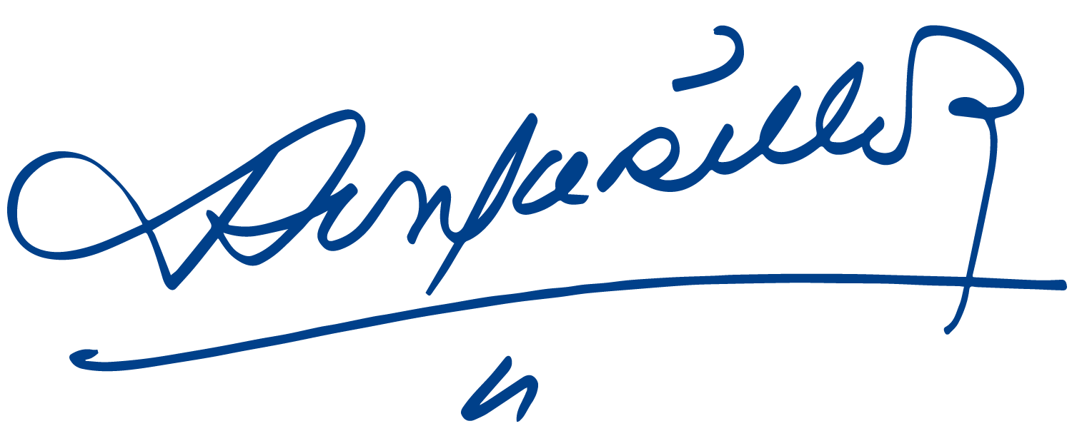
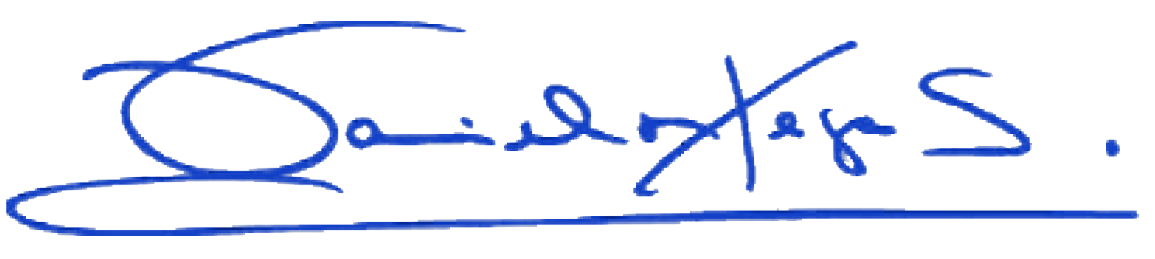

Daniel Ortega Saavedra Rosario Murillo

